**Software Testing Assignment**

Module-1 (Fundamental)

1. **What is SDLC?**

* A Software Development Life Cycle is essentially a series of steps, or phases, that provide a model for the development and lifecycle management of an application or piece of software.

1. **What is software testing?**

* Software Testing is a process used to identify the correctness, Completeness, and quality of developed computer software.

1. **What is agile methodology?**

* Agile SDLC model is a combination of iterative and incremental process models with focus on process adaptability and customer satisfaction by rapid delivery of working software product.

1. **What is SRS?**

* A software requirements specification (SRS) is a complete description of the behavior of the system to be developed.
* It includes a set of use cases that describe all of the interactions that the users will have with the software.

1. **What is oops?**

* Oops is Identifying objects and assigning responsibilities to these objects.
* An object is like a black box.
* Objects communicate to other objects by sending messages.
* Messages are received by the methods of an object.

1. **Basic Concepts of oops**

* Object
* Class
* Encapsulation
* Inheritance
* Polymorphism
* Abstraction

1. **What is an object?**

* Tangible Things
* Roles
* Incidents
* Interactions
* Specifications

1. **What is class?**

* When you define a class, you define a blueprint for an object.
* A class represents an abstraction of the object and abstracts the properties and behavior of that object.
* An object is a particular instance of a class which has actual existence and there can be many objects (or instances) for a class.

1. **What is encapsulation?**

* Encapsulation is the practice of including in an object everything it needs hidden from other objects. The internal state is usually not accessible by other objects.
* Encapsulate in plain English means *to enclose or be enclosed in or as* if in a capsule. In Java, a class is the capsule.

1. **What is inheritance?**

* Inheritance means that one class inherits the characteristics of another class. This is also called a “is a” relationship.
* This is a very important concept of object-oriented programming since this feature helps to reduce the code size.
* Inheritance describes the relationship between two classes. A class can get some of its characteristics from a parent class and then add unique features of its own.

1. **What Is polymorphism?**

* Polymorphism means “**having many forms**”.
* It allows different objects to respond to the same message in different ways, the response specific to the type of the object.
* The most important aspect of an object is its *behavior*

1. **Draw use case on online book shopping**

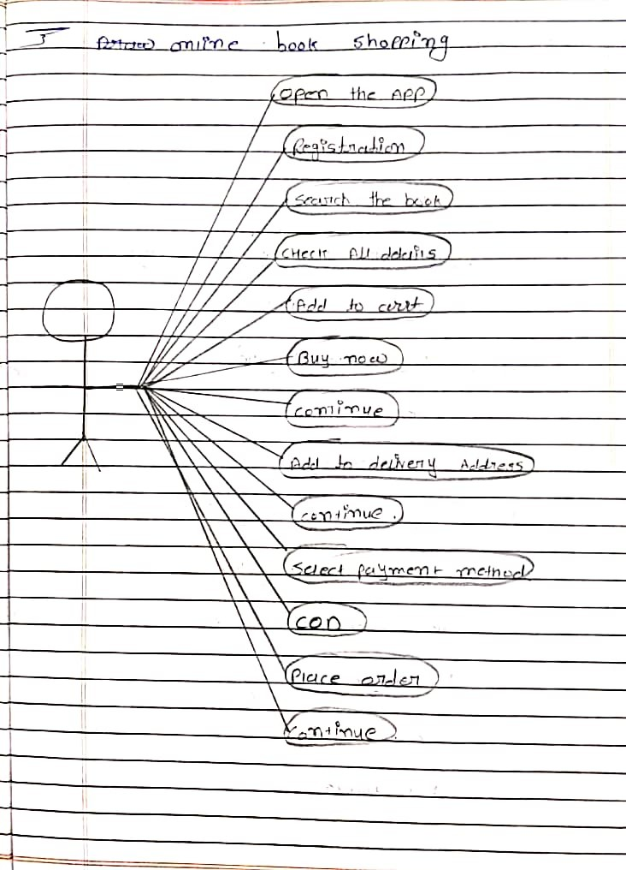

1. **Draw Use case on online bill payment system**

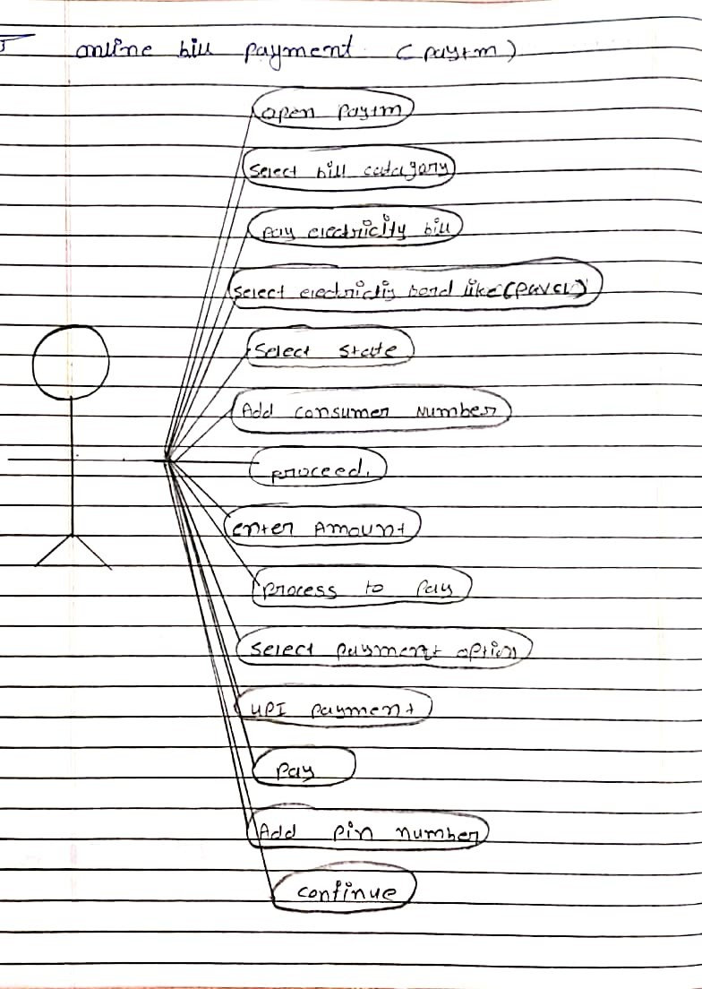

1. **Write SDLC phases with basic introduction**



1. **Explain phases of waterfall model**

* **Verification Phase :-**

1. Business requirement analysis
2. System design
3. Architectural design
4. Module design

* **Code phase :-**

The actual coding of the system modules designed in the design phase is taken up in the Coding phase. The best suitable programming language is decided based on the system and architectural requirements. The coding is performed based on the coding guidelines and standards. The code goes through numerous code reviews and is optimized for best performance before the final build is checked into the repository.

* **Validation phase :-**

1. Unit testing
2. Integration testing
3. System testing
4. Acceptance testing
5. **Write phases of spiral model**

* Spiral Model is very widely used in the software industry as it is in synch with the natural development process of any product.
* When costs there are a budget constraint and risk evaluation is important.
* For medium to high-risk projects.
* Customer is not sure of their requirements which are usually the case.

* Requirements are complex and need evaluation to get clarity.

1. **Write agile manifesto principles**

* Customer satisfaction through early and continuous software delivery
* Accommodate changing requirements throughout the development process
* Frequent delivery of working software
* Collaboration between the business take holder sand developers throughout the project
* Working software is the primary measure of progress
* Agile processes to support a consistent development pace
* Attention to technical detail and design enhances agility
* Simplicity
* Self-organizing teams encourage great architectures, requirements, and designs
* Regular reflections on how to become more effective

1. **Explain working methodology of agile model and also write pros and cons.**

* Agile SDLC model is a combination of iterative and incremental process models with focus on process adaptability and customer satisfaction by rapid delivery of working software product.
* Agile Methods break the product into small incremental builds.
* These builds are provided in iterations.
* Each iteration typically lasts from about one to three weeks.
* **Pros:**
* Is a very realistic approach to software development
* Promotes teamwork and cross training?
* Functionality can be developed rapidly and demonstrated.
* Resource requirements are minimum .
* Suitable for fixed or changing requirements
* Delivers early partial working solutions.
* Good model for environments that change steadily.
* Minimal rules, documentation easily employed.
* **Cons:**
* Not suitable for handling complex dependencies.
* More risk of sustainability, maintainability and extensibility.
* An overall plan, an agile leader and agile PM practice is a must without which it will not work.
* Strict delivery management dictates the scope, functionality to be delivered, and adjustments to meet the deadlines.
* Depends heavily on customer interaction, so if customer is not clear, team can be driven in the wrong direction.
* There is very high individual dependency, since there is minimum documentation generated.
* Transfer of technology to new team members may be quite challenging due to lack of documentation use – case

1. **Draw use case on Online shopping product using COD.**

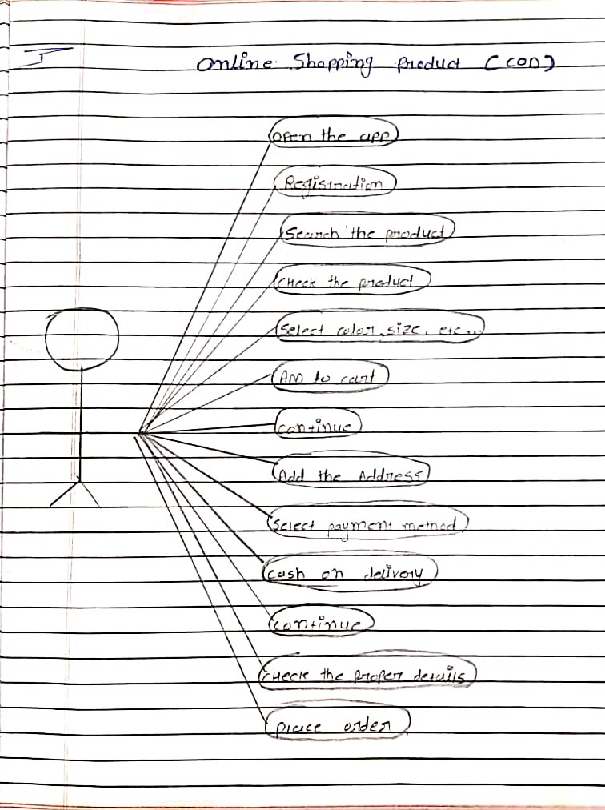

1. **Draw use case on Online shopping product using payment gateway.**

